**Amazon WorkDocs** is a fully Amazon managed, highly-secure, enterprise-level storage and sharing service. Unlike $3 based stored files, you can also share your files with other members of your Organization for the collaboration or review.

Before proceeding for the Amazon WorkDocs, let’s have a look at what Amazon says about its pricing:

With Amazon WorkDocs, there are no upfront fees or commitments. You pay only for active user accounts, and the storage you use. In most regions, WorkDocs costs $5 per user per month and includes 1 TB ofstorage for each user. WorkDocs provides a 30-day free trial with 1 TB of storage per user for up to 50 users. You can invite guest users to log in and view files shared with them at no additional charge.”

As per the above statement, you have 30 days free trial for up to 1 TB of storage that should be more than enough for the learning purpose.

To setup Amazon WorkDocs, you need to perform the following steps:

1. Go to the particular link <https://aws.amazon.com/workdocs/>

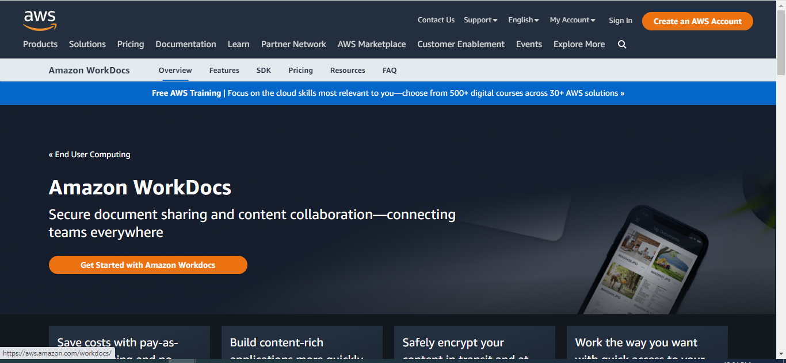

1. Navigate to the **Amazon WorkDocs** home page for the supported region (not every region supports this feature).
2. Click the **Get Started Now** button to proceed to the next page.
3. Here, you will see the **Quick and Standard** setup options as shown in the following figure. For the learning purpose, the **Quick Start** setup guide should be enough. So proceed with this.

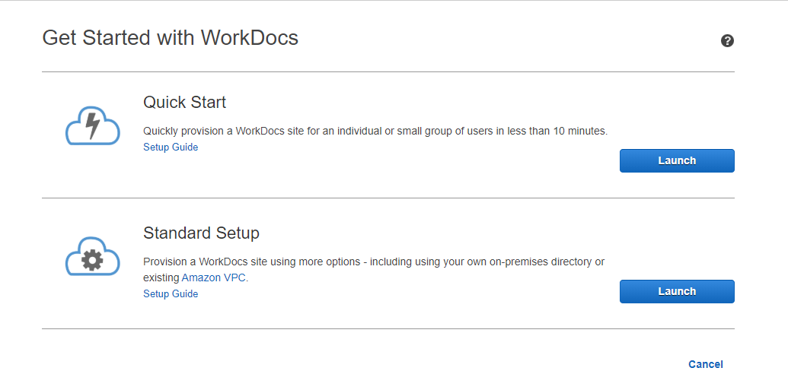

1. On the next page, you need to specify the site URL, email and name details as shown in the following figure.

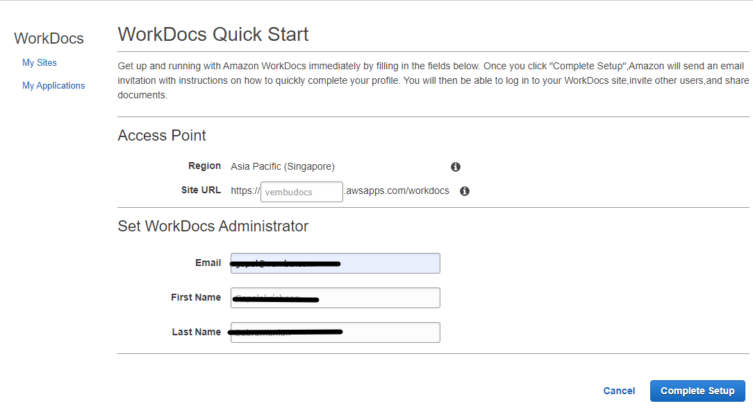

1. Finally, click **Complete Setup** to complete the wizard. Your WordDocs site will be started to initialize and should be available after some time. In fact, you will get an email once your WorkDocs site is ready.
2. Now click the invite link you receive in your email box and set the desired password on the next page.
3. If you didn’t get an invite mail yet, select your created WorkDocs site, click **Actions**, and select **Resend invite e-mail** as shown in the following figure.

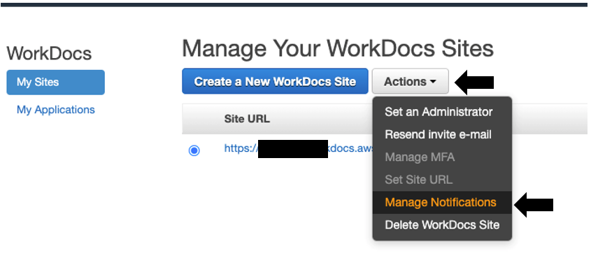

1. Now, click your **WorkDocs site link**, type your registered email ID and login to WorkDocs console. You will see the WorkDocs console similar to as shown in the following figure.

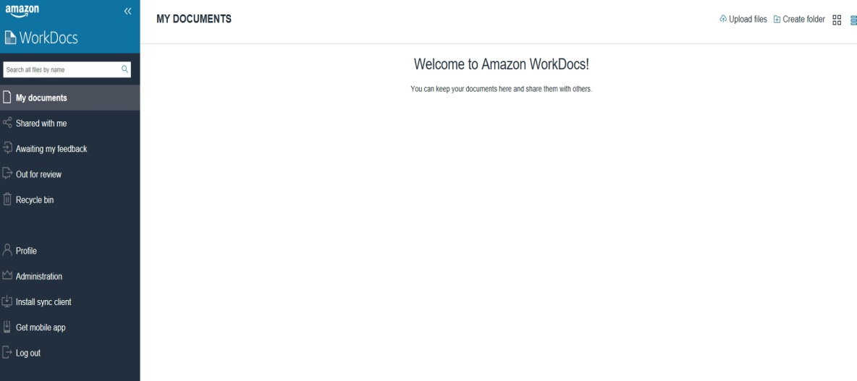

1. In the right pane, you have various options to upload files and folders or create a new folder structure as shown in the following figure.

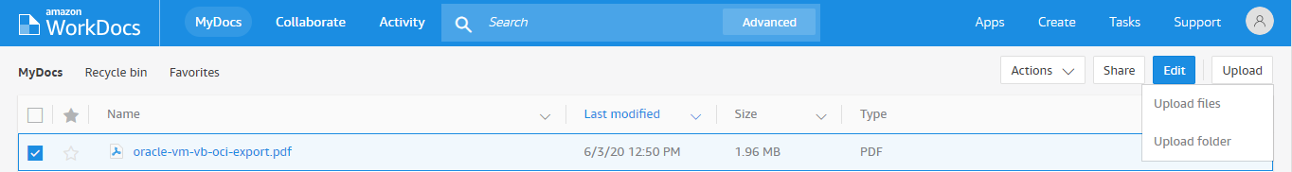

1. In the left navigation pane, there are various options to work with Amazon WorkDocs as shown in the following figure. We recommend you try to explore each one of them for a few minutes to understand and get familiarized with them.

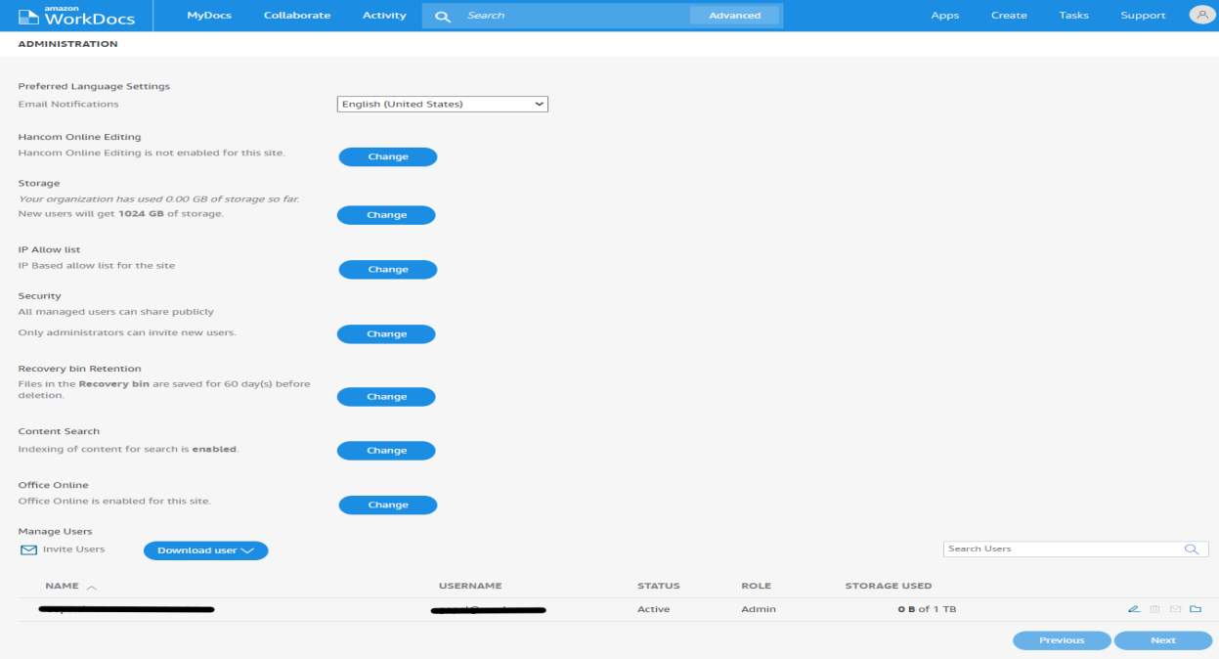

1. Once your activity is done, please delete your WorkDocs site to avoid any unnecessary charges. For this, select your WorkDocs site, click **Actions**, and select **Delete WorkDocs sites**.

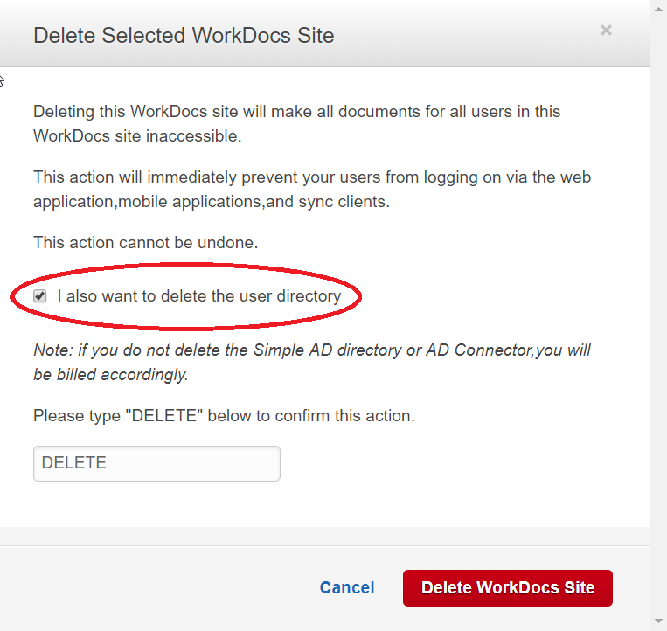

1. Follow the on-screen instructions as shown in the following figure and complete the deletion process